𝟮𝟱 𝗠𝘂𝘀𝘁-𝗞𝗻𝗼𝘄 𝗦𝗰𝗲𝗻𝗮𝗿𝗶𝗼-𝗕𝗮𝘀𝗲𝗱 𝗧𝗶𝗺𝗲 𝗦𝗲𝗿𝗶𝗲𝘀 𝗦𝗤𝗟 𝗜𝗻𝘁𝗲𝗿𝘃𝗶𝗲𝘄 𝗤𝘂𝗲𝘀𝘁𝗶𝗼𝗻𝘀
Time Series SQL questions are among the most frequently asked in Data Engineer, Data Analyst, and BI interviews.
If you're comfortable with window functions, running totals, moving averages, retention analysis, churn calculation, and growth metrics, you'll be able to solve most real-world SQL interview scenarios.
𝗜𝗻 𝘁𝗵𝗶𝘀 𝗴𝘂𝗶𝗱𝗲, 𝘆𝗼𝘂'𝗹𝗹 𝗹𝗲𝗮𝗿𝗻:
• Time Series fundamentals
• Running Total & Cumulative Sum
• LAG() & LEAD() use cases
• Day-over-Day (DoD) analysis
• Week-over-Week (WoW) growth
• Month-over-Month (MoM) growth
• Year-over-Year (YoY) growth
• Moving Averages (3-Day & 7-Day)
• Rolling 12-Month Sales
• Peak Sales Detection
• First Purchase Analysis
• Cumulative Active Users
• User Retention (Day 1, Day 7, Day 30)
• Monthly Churn Rate
• Window Functions for real interview scenarios
These are practical SQL patterns used in production systems and regularly asked during interviews at top product and service-based companies.
💙 Like 👍 & Save 🔖 for later.
🔄 Share this post if it adds value to your interview prep.
Comment below 👇 Which Time Series SQL question do you find most challenging?
𝗙𝗼𝗿 𝟭:𝟭 𝗴𝘂𝗶𝗱𝗮𝗻𝗰𝗲
https://lnkd.in/gxjZT5P3
🚀 𝗟𝗲𝘃𝗲𝗹 𝘂𝗽 𝘆𝗼𝘂𝗿 𝗗𝗮𝘁𝗮 𝗘𝗻𝗴𝗶𝗻𝗲𝗲𝗿𝗶𝗻𝗴 𝗽𝗿𝗲𝗽:
🔹 𝗦𝗤𝗟 𝗜𝗻𝘁𝗲𝗿𝘃𝗶𝗲𝘄 𝗠𝗮𝘀𝘁𝗲𝗿𝘆 – 𝟮𝟬𝟬+ 𝗤𝘂𝗲𝘀𝘁𝗶𝗼𝗻𝘀
https://lnkd.in/dYJb42RH
🔹 𝗣𝘆𝗦𝗽𝗮𝗿𝗸 𝗜𝗻𝘁𝗲𝗿𝘃𝗶𝗲𝘄 𝗣𝗿𝗮𝗰𝘁𝗶𝗰𝗲 – 𝟵𝟲 𝗤𝘂𝗲𝘀𝘁𝗶𝗼𝗻𝘀
https://lnkd.in/dwCEinvH
🔹 𝗗𝗮𝘁𝗮 𝗘𝗻𝗴𝗶𝗻𝗲𝗲𝗿 𝗣𝘆𝘁𝗵𝗼𝗻 𝗜𝗻𝘁𝗲𝗿𝘃𝗶𝗲𝘄 – 𝟭𝟬𝟬 𝗤𝘂𝗲𝘀𝘁𝗶𝗼𝗻𝘀
https://lnkd.in/dwKVeFf7
👉 Follow Anuj Shrivastav for more Data Engineering interview content.
hashtag#SQL hashtag#DataEngineering hashtag#DataEngineer hashtag#SQLInterview hashtag#WindowFunctions hashtag#Analytics hashtag#DataAnalytics hashtag#BigData hashtag#PySpark hashtag#TechCareers hashtag#InterviewPreparation

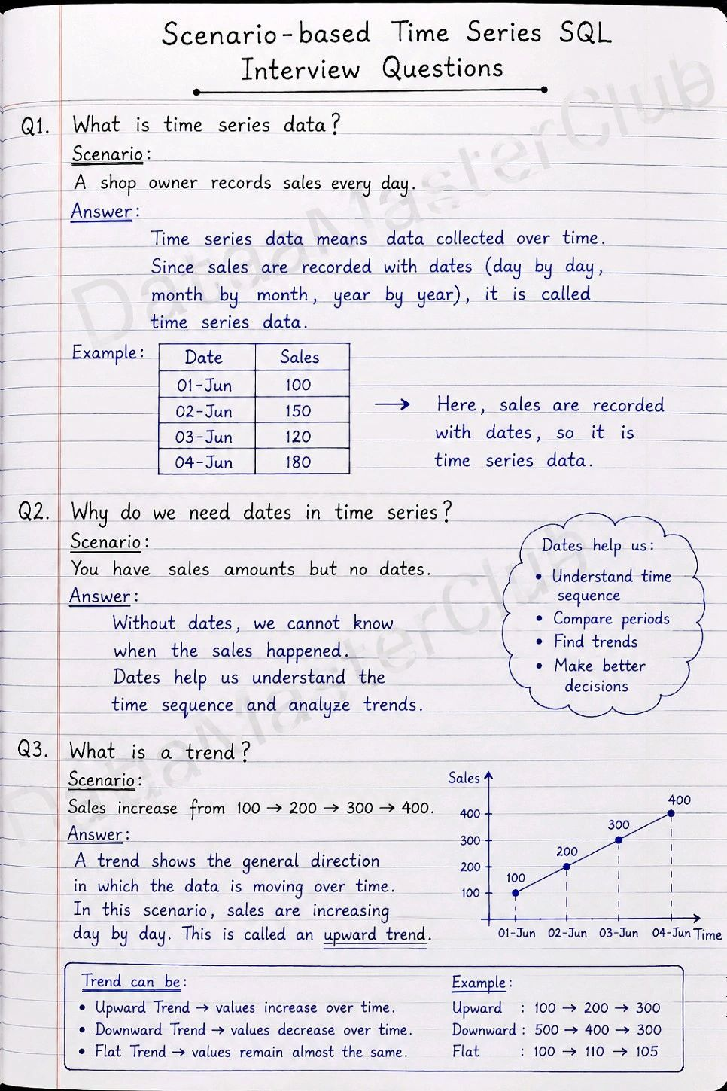
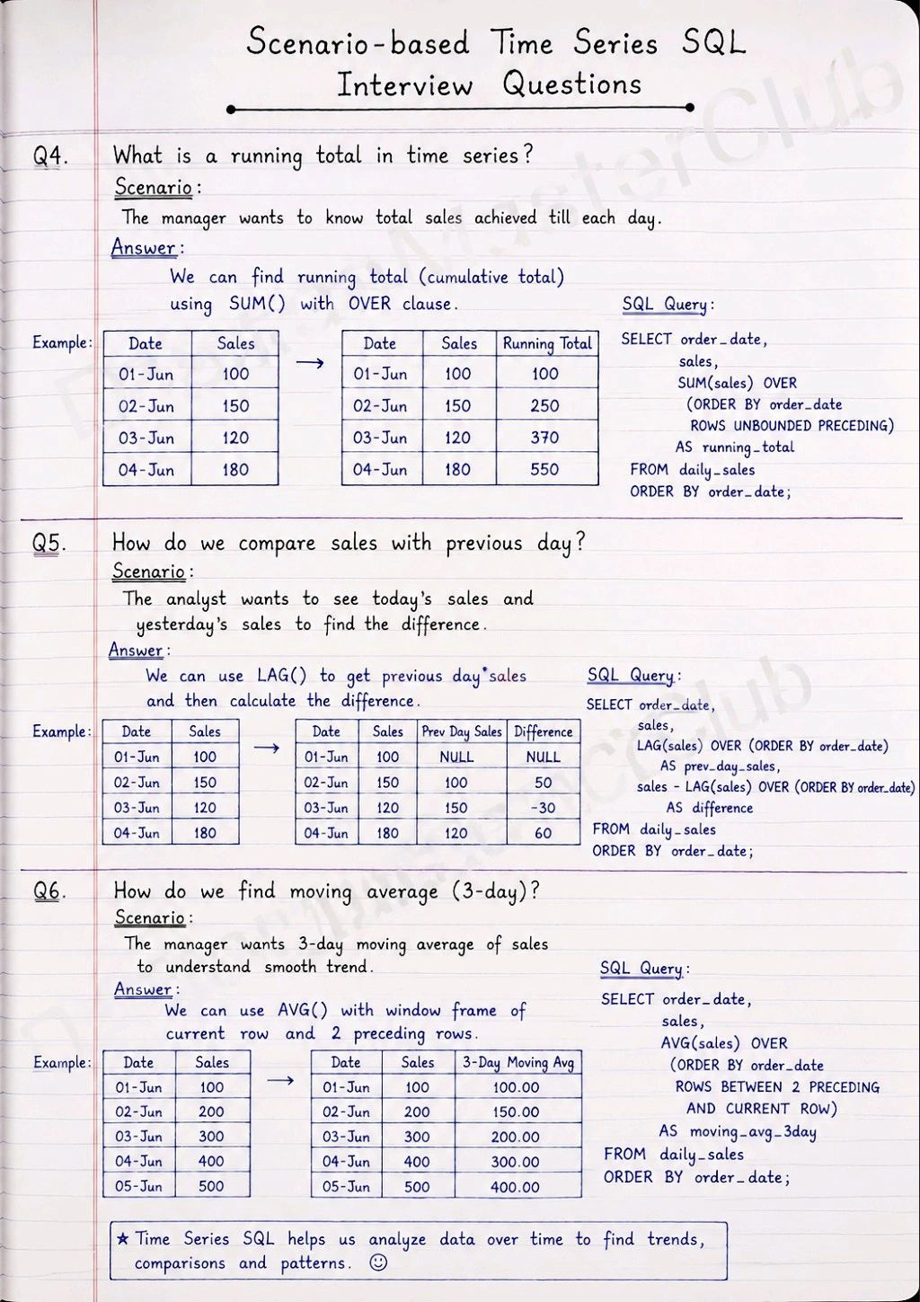
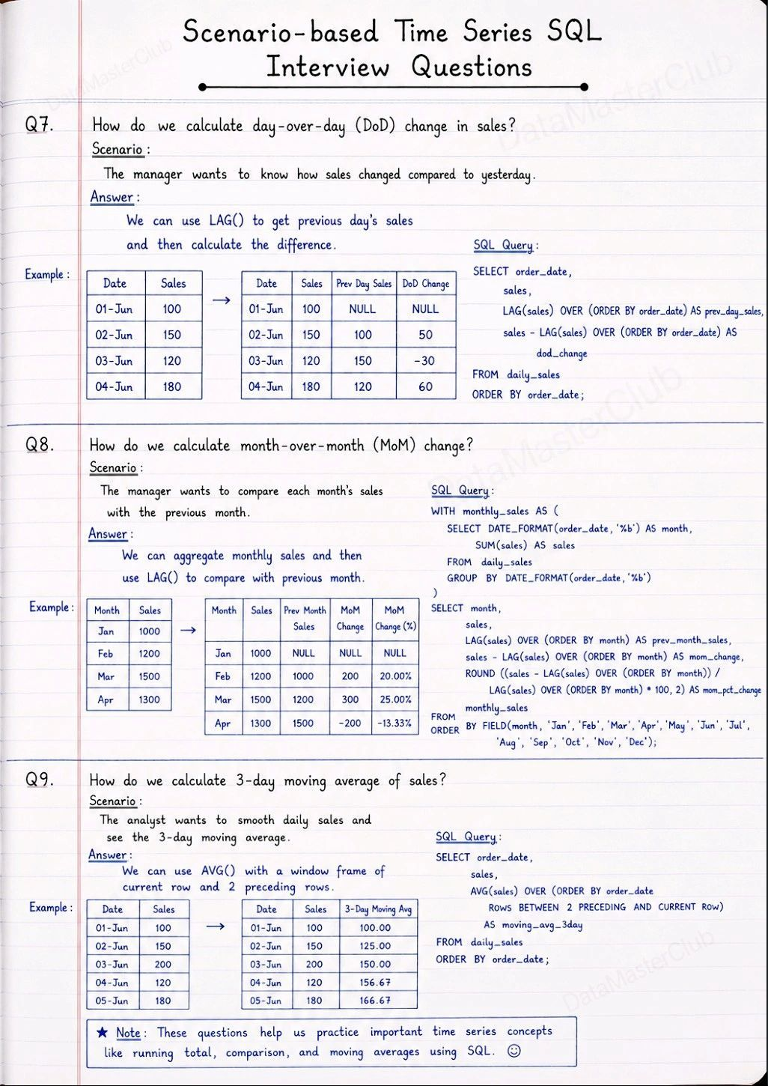
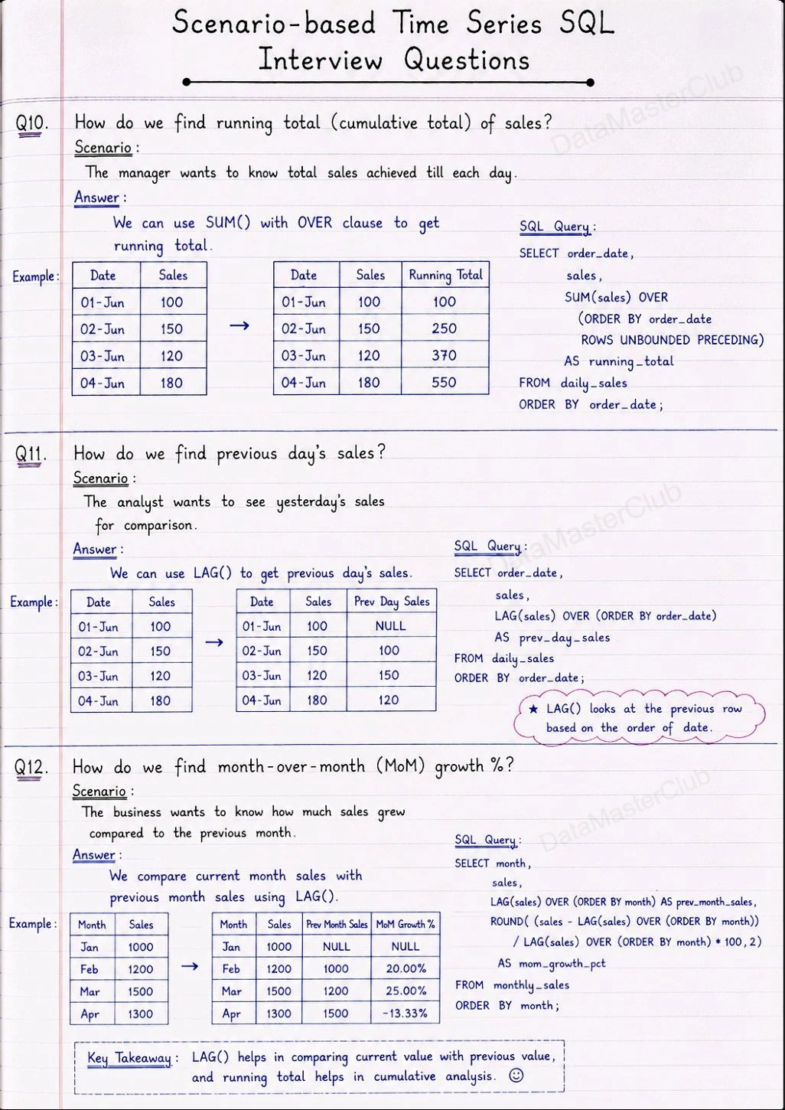
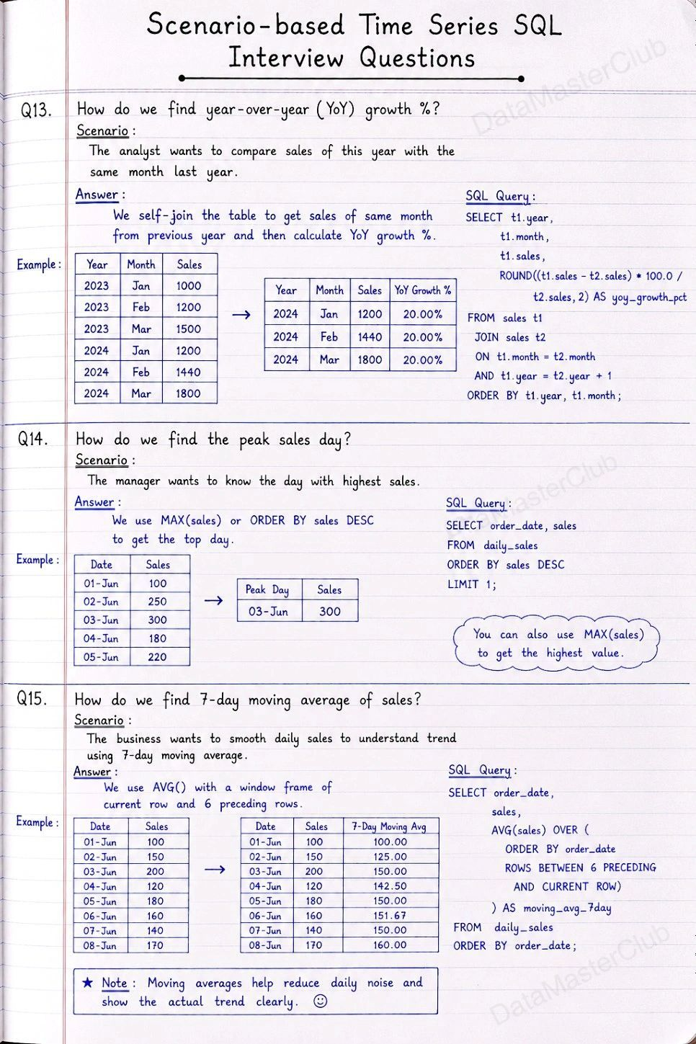
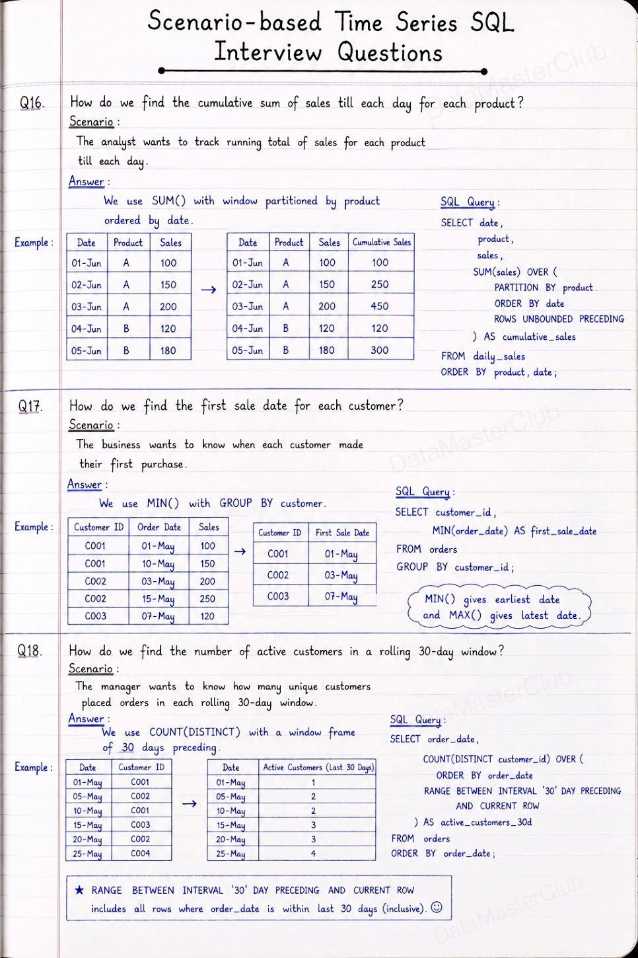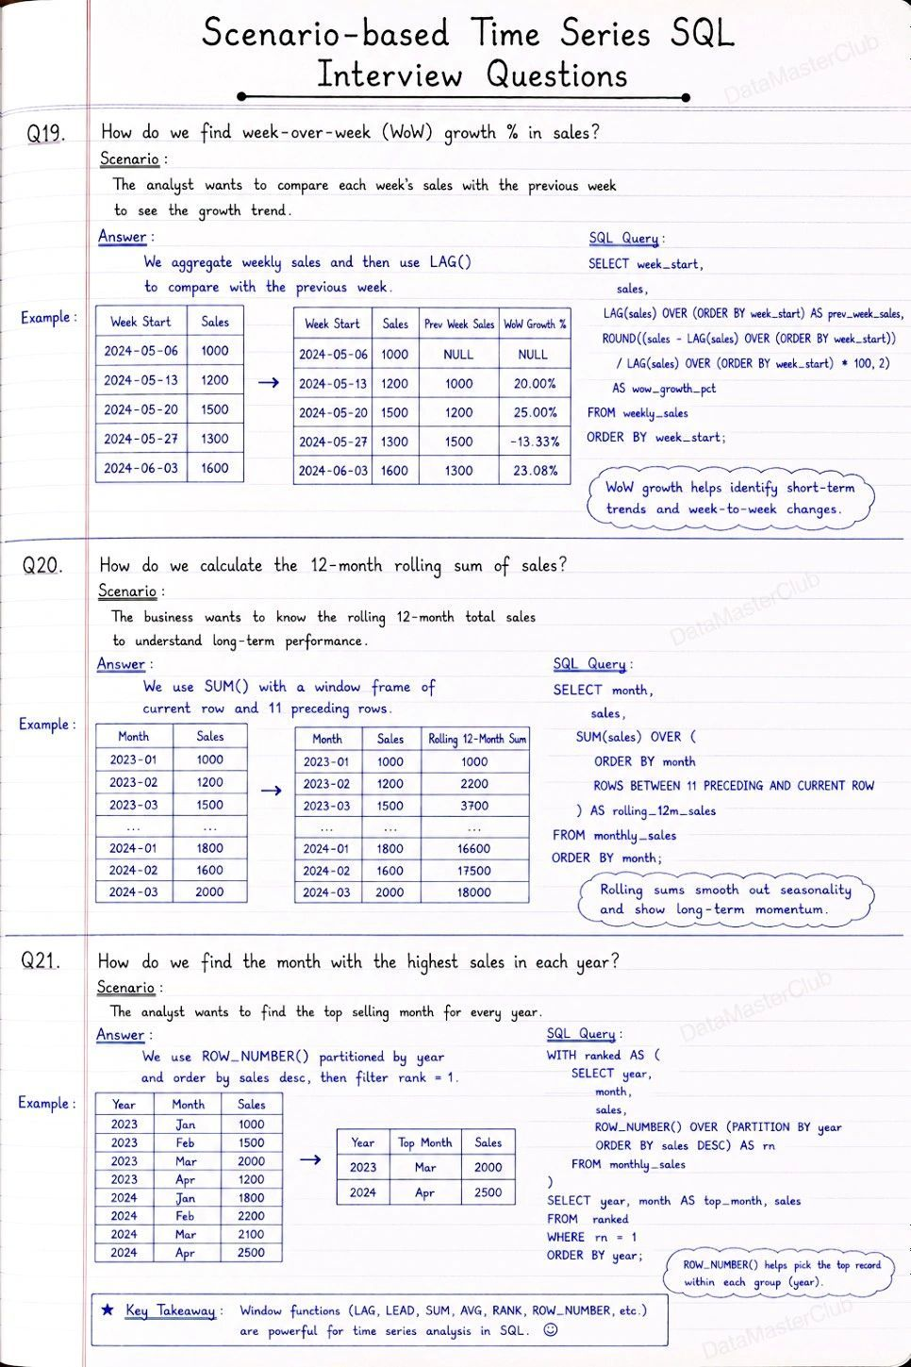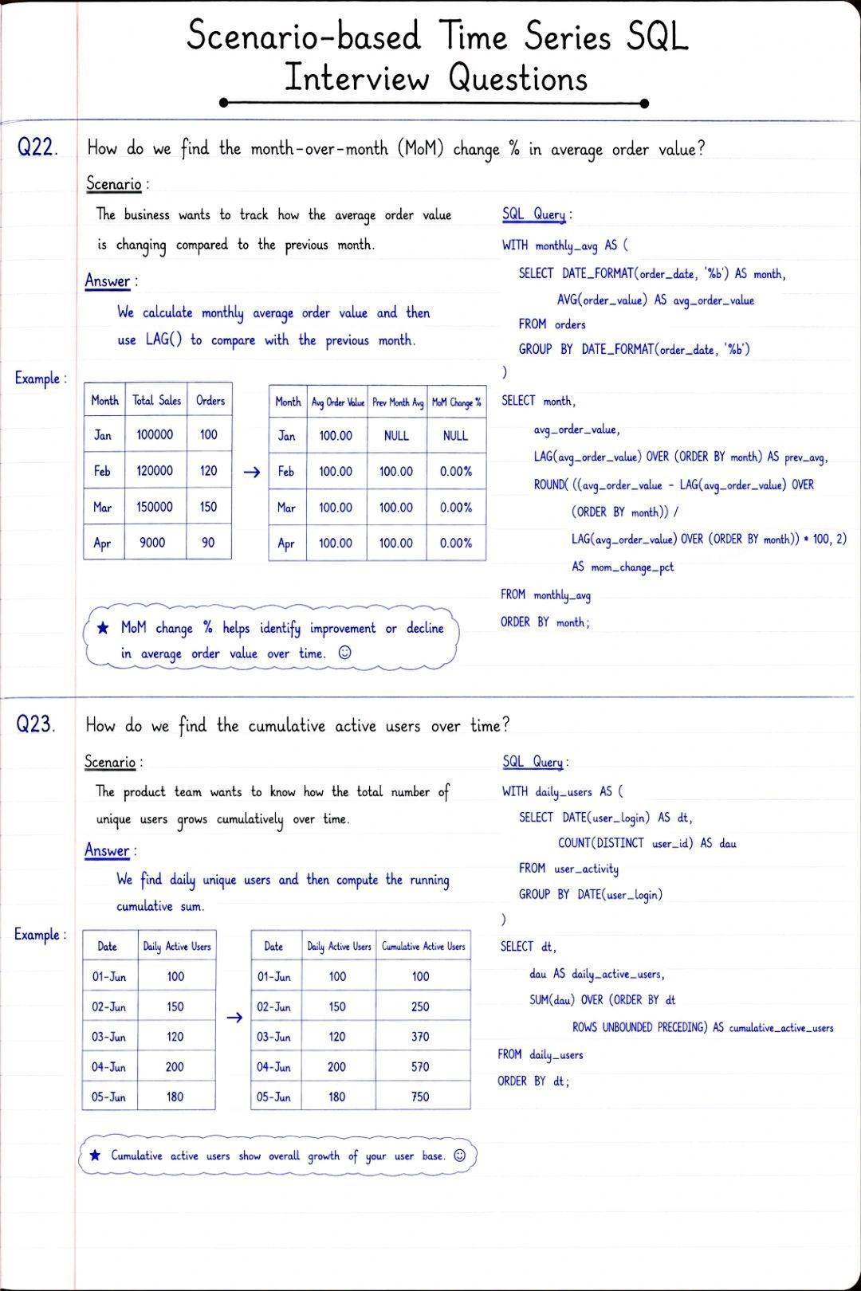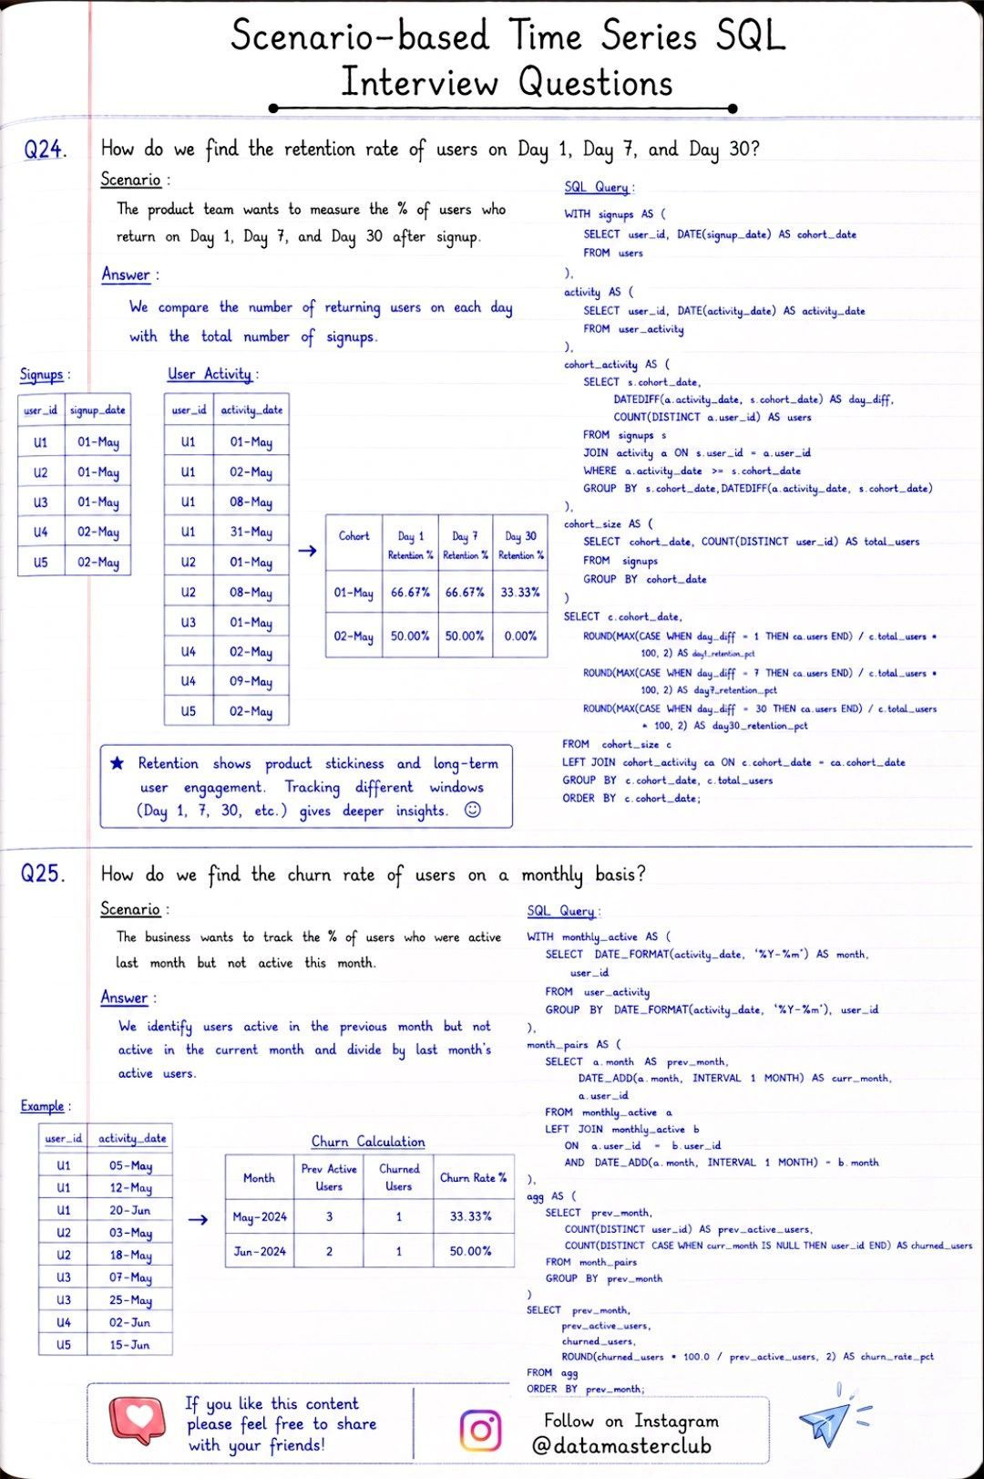

Stop memorizing SQL syntax. Start memorizing patterns.
I put together the 18 SQL interview questions that keep showing up across Data Analyst, Data Engineer, and Backend interviews — with ready-to-use answers.
Inside you'll find patterns for:
🔹 Nth highest salary (DENSE_RANK)
🔹 Detecting & deleting duplicates safely
🔹 Finding gaps in a sequence (LEAD)
🔹 Running totals & 30-day rolling revenue (window functions)
🔹 Top N per group (Top 2 earners per department)
🔹 Users who bought both A AND B
🔹 Revenue by category — including zero sales (LEFT JOIN + COALESCE)
🔹 Conditional aggregation dashboards (CASE + SUM)
Most interviewers aren't testing if you know SQL syntax.
They're testing if you can recognize the pattern behind the question.
Once you see that "top N per group" is always a window function + rank filter, and "missing records" is always a LEFT JOIN + IS NULL — these questions stop feeling random.

